# Characterizing Riparian Vegetation Using the Riparian Classification from LiDAR (RCL) Tool in ArcGIS

# Updated May 6th, 2020

Authors: Sky Jones1; Racha El Kadiri2, PhD; Henrique Momm3, PhD

1Middle Tennessee State University, [rj3h@mtmail.mtsu.edu](mailto:rj3h@mtmail.mtsu.edu)

2Assistant Professor, Middle Tennessee State University, [racha.elkadiri@mtsu.edu](mailto:racha.elkadiri@mtsu.edu)

3Asssociate Professor, Middle Tennessee State University, [henrique.momm@mtsu.edu](mailto:henrique.momm@mtsu.edu)





## Abstract

*The Riparian Classification from LiDAR (RCL) tool is a Python script designed to classify riparian land cover. The tool accepts a folder of LiDAR binary (*.las*) files and outputs a land use raster as well as supporting data files such as digital elevation and slope models. It is available as an ArcGIS script tool, meaning it can be called using the same graphical user interface that standard ArcGIS tools use. There are currently two versions of this tools: one that uses a pretrained model to classify land cover, and one that accepts training data to train a custom classification model. This document details how to set up and use both version of the RCL tool.*

## Assumptions

This walkthrough assumes that the user is generally familiar with ArcMap and has already obtained LiDAR data in *.las* format for their study area, either by directly downloading *.las* files or unpacking *.laz* (compressed *.las*) or *.zlas* (ESRI compressed *.las*) files. Optimal results will be achieved with LiDAR data having a point density of over 1pt/m2.

It is not necessary that the user is familiar with any scripting languages. The *.las* files for the study area should be contained within a single folder with no other files.

The RCL tool requires ArcGIS 10.X and valid Spatial and 3D Analyst licenses to run.

## Walkthrough

1. *Downloading the RCL Tool*

The RCL tool can be found at <https://github.com/rsjones94/nrcs_rcl>. To download the tool, click the green “Clone or download” button and select “Download ZIP” **(Figure 1)**. Unpack the zipped folder in a location that can be easily found later. This folder contains the RCL Python script and the associated ESRI Toolbox file, as well as supporting documentation (including this walkthrough).

1. *Running the RCL Tool*

To open the RCL interface, open ArcCatalog. The Catalog can be accessed either directly in the ArcCatalog application or through ArcMap by clicking the “Catalog” button in the toolbar. In the Catalog navigate to the folder downloaded in the previous step. Double click on *rcl.tbx* to expand it, then double click the *Riparian Classification from LiDAR (pretrained)* or *Riparian Classification from LiDAR (custom)* tool to open the tool dialogue **(Figure 2)**. A graphical user interface similar to standard ESRI tools will appear. Fill each field as instructed by the tooltips.

* + If you are using the pretrained version of the tool, the only required input is the folder if *.las* files. You may optionally supply a file representing a flow network and buffer width to restrict the area of investigation; this typically shortens the tool’s runtime.
  + If you are using the custom version of the tool, both the folder of *.las* files and a shapefile of training data are required as input. The training shapefile should be created using ArcGIS’s *Image Classification* toolbar, and each entry should represent a distinct landcover class **(Figure 3)**. Though a stream network file can be specified for the custom RCL tool, this will not alter runtime because the full extent of the rasters are generated regardless for model training purposes.

IMPORTANT: If you are using the pre-trained RCL tool, your *.las* files MUST be in a projected coordinate system that uses meters as its XY units. The classification relies on scale-dependent phenomena; XY units supplied as feet or degrees may result in loss in classification accuracy. If you are supplying your own training data, the input *.las* must be in a projected coordinate system, but do not need to use meters as the coordinate system’s XY units.

When ready, hit run. Processing time varies with study area size and LiDAR point density. For large study areas (*.las* files totaling over 5gb) processing times of 30 minutes and beyond are common if a stream network shapefile is not supplied. Tool progress can be monitored under “Messages” in the Results pane, which is accessible in the Geoprocessing dropdown menu. The tool will progress through steps similar to the following, depending on the model version and input:

Generating footprint and .lasd>Generating DSM>Generating DEM>

Generating DHM>Generating slope rasters>Classifying cover>Classification complete

Once the tool has finished running, the classification shapefile can be found in the output folder specified in the tool parameters along with a support folder full of derived data products. The values in the classification file will depend on whether the classification scheme selected was “binary” or “ternary” (if the pretrained RCL tool was used) or the FID codes of the input training file (if the custom RCL tool was used).

## Model Details and Limitations

It is recommended that all LiDAR data for the study area is coterminous. The tool generates interpolated rasters, meaning data gaps due to distant, unconnected LiDAR tiles will be interpolated across even if the distance is large. This results in expensive, unnecessary computations that slow classification speed.

Additionally, though this model is most accurate within the riparian corridor, it will output a raster that classified the entirety of the LiDAR input unless a clipping shapefile is supplied **(Figure 4)**. Because classification done outside the riparian corridor has limited accuracy when using the pretrained RCL tool, it is recommended that the user either clip the output classification using a riparian buffer polygon or (preferably) supply a stream network shapefile at runtime. This is less important for the custom RCL tool, whose accuracy is largely dependent on the quality of the training data.

## Figures

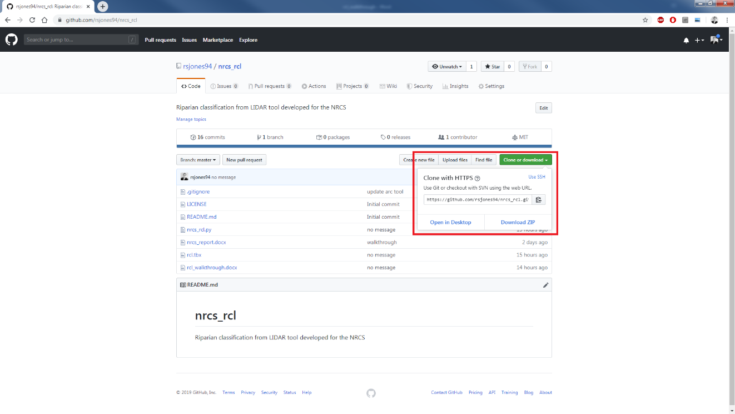

**Figure 1.** The RCL tool can be downloaded from the *nrcs_rcl* Github repository.

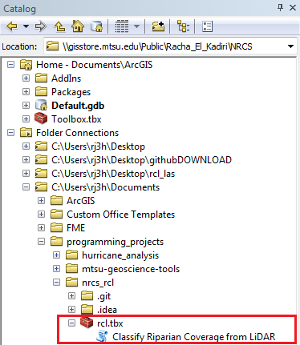

**Figure 2.** The directory structure of the RCL toolbox in the Catalog. Double-clicking *Classify Riparian Coverage from LiDAR* will launch the RCL tool user interface.

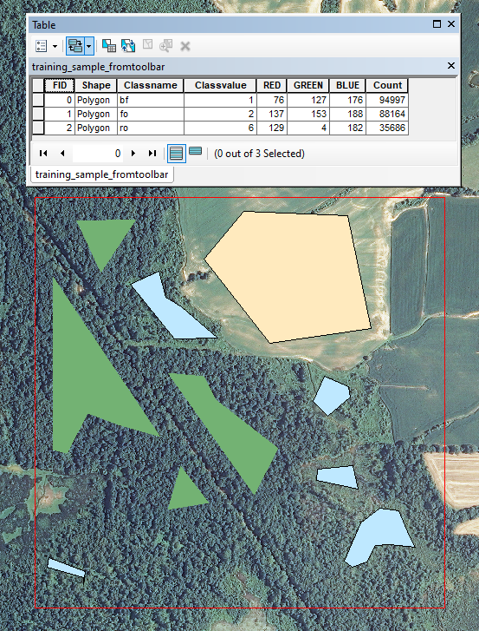

**Figure 3.** An example training shapefile for use with the custom version of the RCL tool, created using the *Image Classification* toolbar. Three classes (bare field, forest, and rough vegetation) are present. The landcover classification file created by the custom RCL tool will map onto the FID of the input training file (e.g., a GRIDCODE of 0 in the output shapefile corresponds to the entry with an FID of 0 in the input training file).

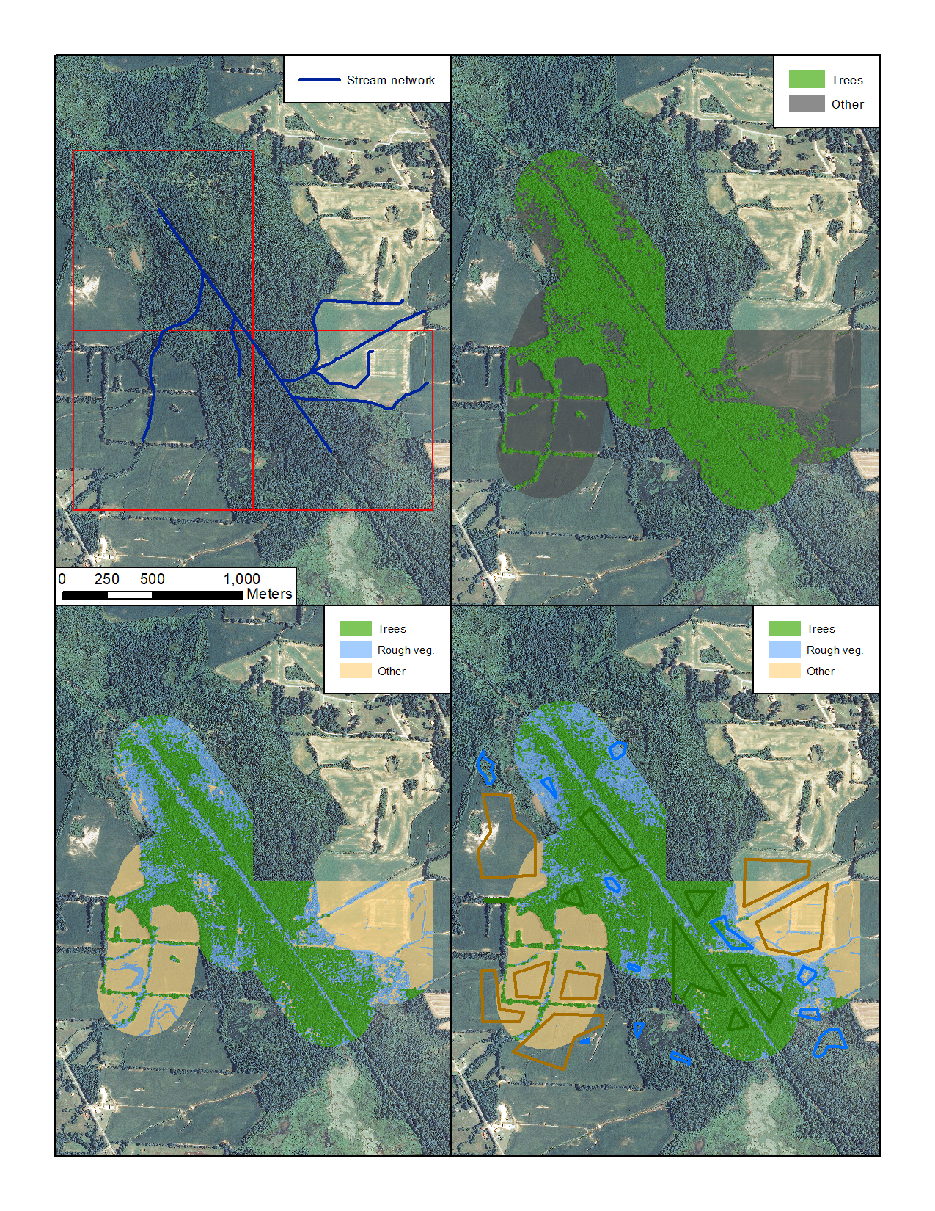

**Figure 4.** Sample outputs for various version of the RCL model. Output was restricted to the 250m buffer surrounding the stream network. Upper left: footprint of input *.las* files and stream network. Upper right: pretrained binary model. Bottom left: pretrained ternary model. Bottom right: custom trained model and training classes used to train model.

## Acknowledgements

Many thanks to the National Resources Conservation Service for providing funding for this project.